God thank you for your grace and mercy.

The order that is shown in freely traded financial markets and the entire universe is a miracle and we pray for your guidance in making a living and helping others.
Thank you. In Jesus name Amen.

Just to start here is our base forming in USDJPY 60 min.
(2 charts to show sideways strengthening movement and support becoming resistance, this chart is after a long price descent)

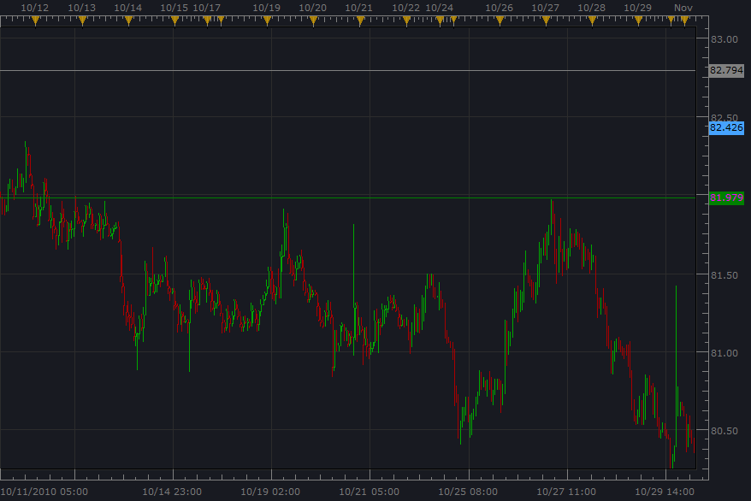

We are checking USDJPY because EURUSD is on a downturn, USDCHF is strengthening, and GBPUSD (pos. corr.) is on it’s way top finishing a zigzag in the larger time frame as EURUSD and is now on it’s way into a sellers impulsion phase.

Here is the second USDJPY chart which shows a fast break from our “support became resistance” range area, and we also notice a pennant continuation pattern. So this will be a good pair to follow as EURUSD gets going, USDCHF keeps strengthening and GBPUSD forms a top.

By the way if trouble reading 15 min, just squish the candles together so we can get the wave count and sentiment.

Like this…………we just had a down trend impulsion phase that finished near psychological support 80.00 (not to mention 261.8% extension Fib. from the top, which indicates a bottom forming), and our other currency pairs are correlating with this analysis.

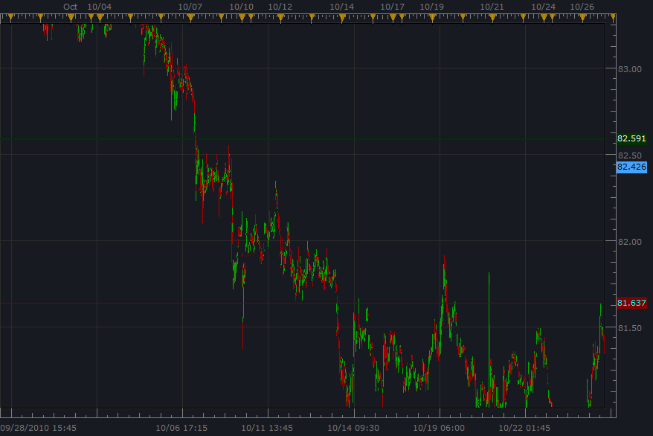

USDJPY more of the 15 min to right, this helps us know what is forming, and “locate” the base object/turning point/end of corrective phase in this time frame and then go to 1min for our opportunity and Fibonacci guidance forecasting.

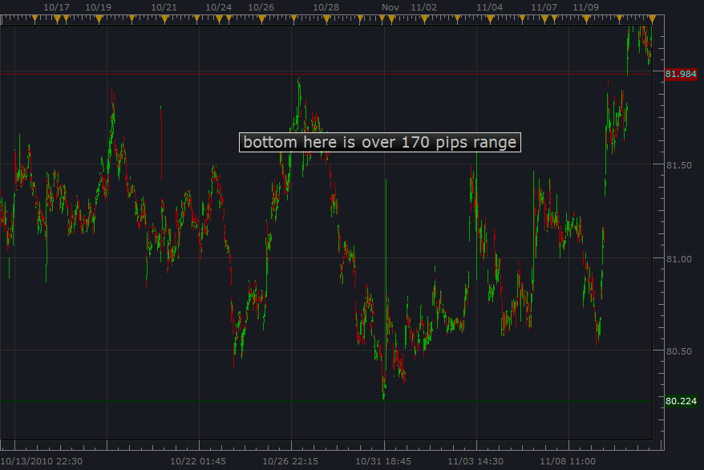

So this will be our 15 min range forecast using fib. lines 0-50% at the base and top.

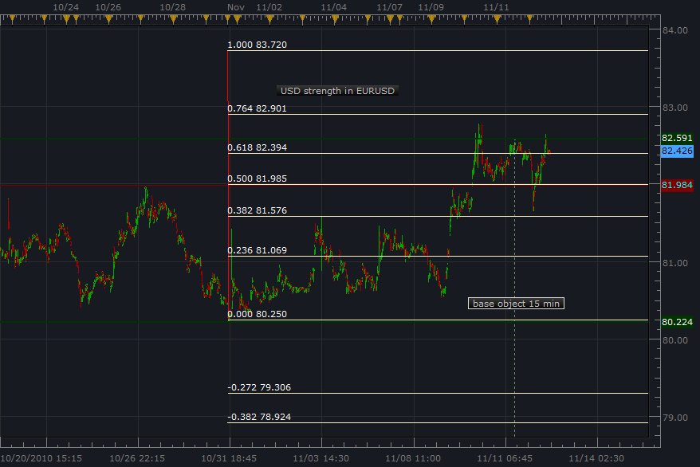

We can not that we already have a “buyer sentiment” break here past the 50% fib. line. ☺

Here is an awesome example of a “market cycle” happening in 1 min. candles WOW! This happens right at the price turn. How about that for sentiment. ☺

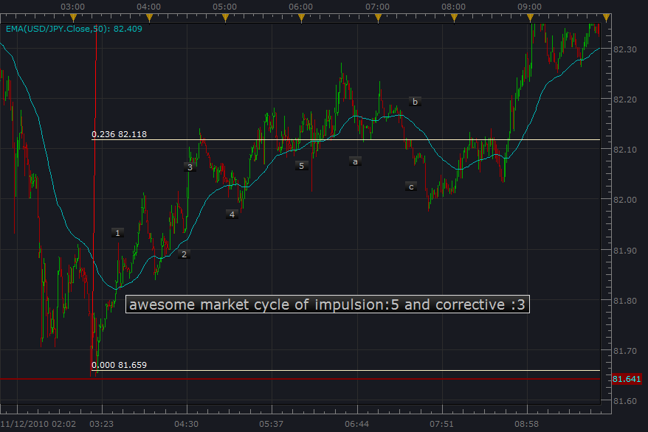

And here is a base object type thing, note that price crossed the 50 EMA and then moved…(we can use price crossing the 50 EMA in the direction of the prevailing trend….so if we know that…good deal…)

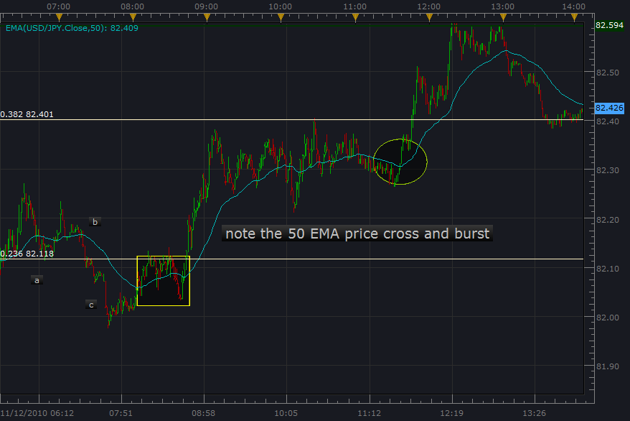

So we here we go, the Forex market opens this evening, and our 1min candles should start developing this support/resistance area and showing buyer sentiment.

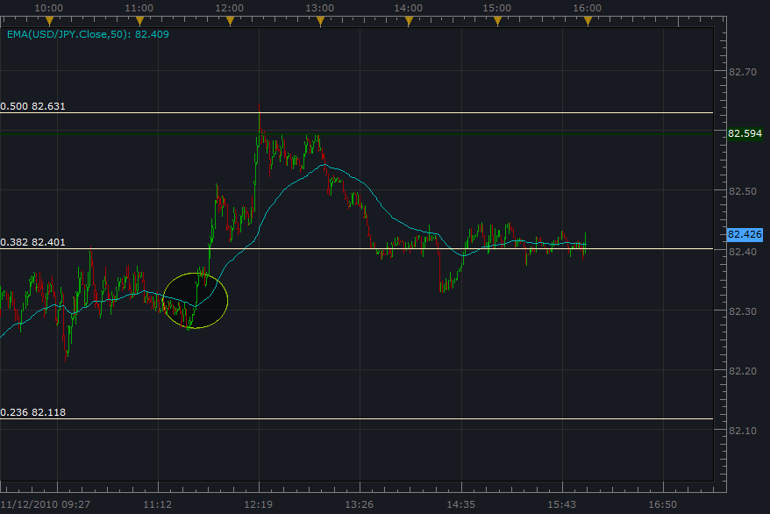

The last chart is an interesting view of a range gathering strength. ☺
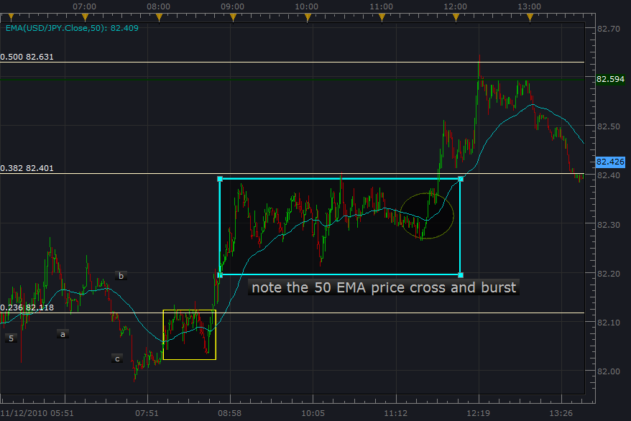

O.k. so now as the market opens, we use this major area as a gauge.
Major cluster areas are also called base objects..

