Hey guys, so here is the thing…..
These three FX trades are examples of the “just spend a moment to find a structure”
Then “set it and forget it” thang….just starting this without checking any exterior
Parameters like larger time frames, or fundamentals.

Just noticed the EMA (50 and closed) was leading the price movement and the
structure was what seemed to be a reversal pattern.
The thought is that, we either have continuation pattern structure or a reversal
Pattern structure. We set the Entry Order and a fixed trailing stop, also a
Measured move (or so) Limit order. Measured move is the distance between
The pull back and the price testing zone (or MBO-Momentum Breakout) area.
Here’s the pictures on that one:
USD/CHF Reversal pattern looking thang
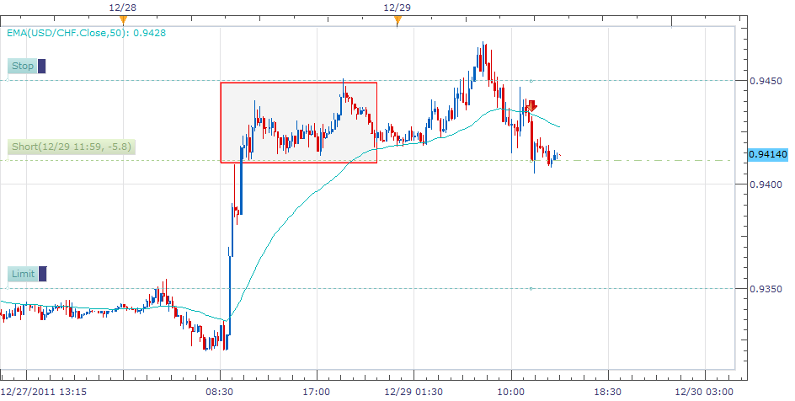
So here is the same currency pair checking the next day.

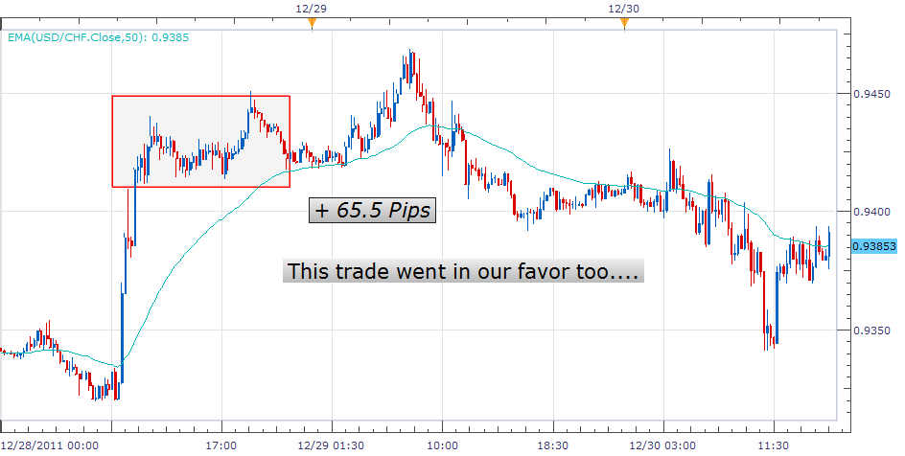

We can notice that we are glad we put our limit order the measured move away from the MBO point. It went about that far. Our friends say, “there ya go, good. Don’t get stingy with the trade”

Here is one that did not go the way we thought….
On the next page, we thought it may have been a “Top-reversal pattern”. It turned into a “Bottom thang” or maybe this was one of those. “drop-base-rally” events? How do we know if this is the structure present for the future trades? Hmmm. It’s good to ask the question….the trade did not start because the lower MBO point was not broken through. Interesting…
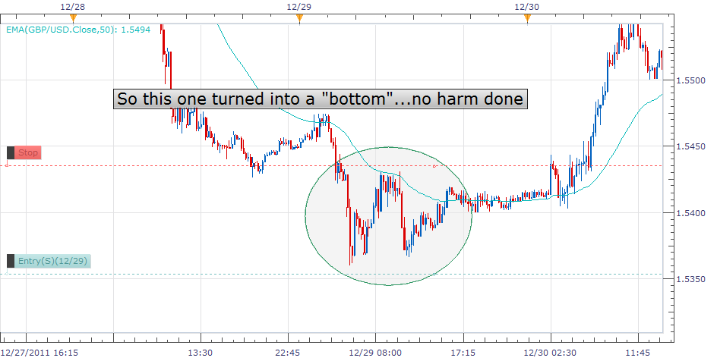

And here is the USD-JPY trade.

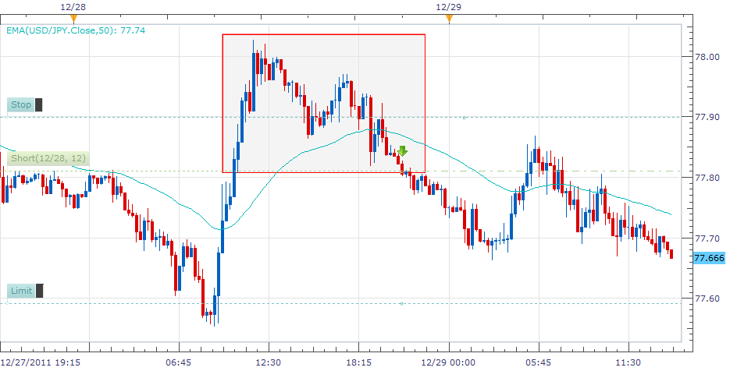

Then the next day:
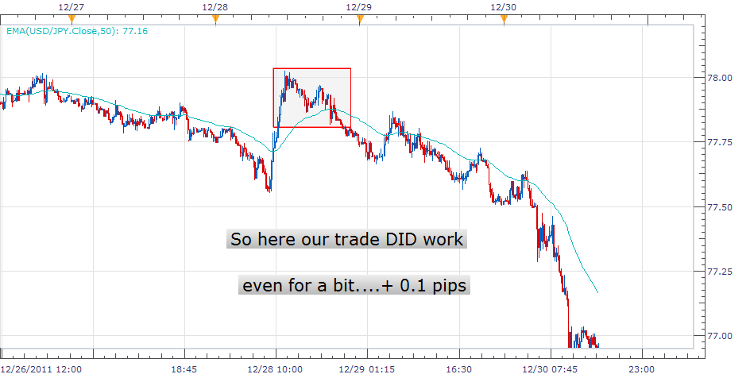

So actually this one was a reversal pattern that “retested” the MBO zone then, really continued on. Some people call that reversal pattern that turned into the new Impulsion phase, “a seed” or “base object”. The trailing stop must have stopped the trade. Or something like that.
So anyway, take some time away. It’s this Keep IT Sweet and Simple concept that makes the discovery fun. Later, we can find out WHY certain trades go the other direction? Maybe so. For now, it’s a structure. Continuation pattern, or reversal pattern. Are there previous impulsions (clear movements in price) that tell us that Price movement shows directional sentiment. Someone said that the 12345 wave principle/Elliot wave doesn’t as much apply in the 15 min time frames, or maybe so. Away we go…..peace….

